1. Consider the system defined by

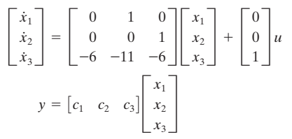

Except for an obvious choice of c1=c2=c3=0, find an example of a set of c1, c2, c3 that will make the system unobservable.

1. Obtain the transfer function *E*o(s)/*E*i(s) of the electrical circuit shown in Figure

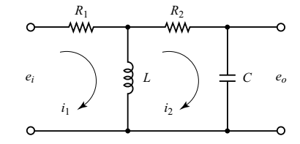

1. Simplify the block diagram shown in Figure 2–21. Then obtain the closed-loop transfer function C(s)/R(s).

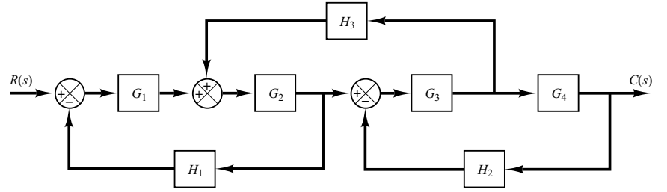

1. Draw the signal low graph of the following electrical circuit and find its transfer function using Mason’s gain formula.

